Grazioso Salvare Animal Rescue Dashboard

# Created by Mohamed Elhassan

**Created by Mohamed Elhassan** **1**

Project Overview 2

[Functionality  
Features](#) 3

Tools and Libraries 4

[How to Run the Project  
Prerequisites](#) 5

Running the Dashboard 5

Screenshots 6

Challenges and Solutions 9

Pie Chart Readability 9

Map Zoom and Interactivity 9

License 9

## Project Overview

This project is a web application dashboard developed for Grazioso Salvare, an international rescue-animal training company. The dashboard allows users to interact with and visualize data from a MongoDB database of shelter animals. It includes filters for different rescue types and provides geolocation data, breed distribution, and other relevant details about animals suited for rescue operations.  
The dashboard is designed to help the client easily identify dogs for training by filtering them based on predefined criteria.

## Functionality Features

**1. Rescue Type Filters:**   
- Users can filter animals based on the type of rescue training:   
 - Water Rescue  
 - Mountain or Wilderness Rescue  
 - Disaster or Individual Tracking  
 - Reset (to show all data).  
- Selecting a filter updates both the data table, breed distribution chart, and geolocation map to display relevant animals.  
**2. Interactive Data Table:**  
- Displays the animal details from the database, such as breed, age, and outcome type.  
- The table responds to the selected filter and allows users to click on rows to highlight animals on the map.  
**3. Breed Distribution Pie Chart:**  
- Displays the breed distribution for the selected rescue type.  
- Shows the top 5 breeds, while the less common breeds are grouped under "Other" for readability.  
**4. Geolocation Map:**  
- Displays the location of animals on a map based on their shelter's coordinates.  
- Zooms in on the location of a selected animal when clicked in the data table.  
- Popups display additional details such as the animal's breed and name.

## Tools and Libraries

The project uses the following tools and libraries:  
  
**1. MongoDB:** Used as the database to store and retrieve the animal shelter data. The CRUD operations are handled through a Python module.  
**2. Dash (Plotly):** A Python framework used for building web applications. Dash is utilized for the interactive web dashboard, data visualizations, and user interface components.  
**3. Dash Leaflet:** A library that integrates leaflet.js with Dash for creating interactive maps.  
**4. Pandas:** Used for data manipulation and organizing MongoDB query results into tables and charts.  
**5. Plotly Express:** Used for creating the pie chart to visualize breed distribution.

## How to Run the Project Prerequisites

- Python 3.x  
- MongoDB (configured and running with the appropriate collections)  
- Install the necessary Python libraries by running the following:

```bash  
pip install jupyter_dash dash dash_leaflet plotly pandas  
```

### Running the Dashboard

1. Ensure that the MongoDB instance is running and accessible with the correct credentials and data.  
2. Place the provided files (ProjectTwoDashboard.py, crud_module1.py, and GSlogo.png) in the same directory. In this case they were on the desktop.  
3. Open the ProjectTwoDashboard.ipynb or .py file in Jupyter Notebook or any Python IDE.  
4. Run the file.  
5. Access the dashboard in your browser (typically at http://127.0.0.1:19750/).

## Screenshots

**- Initial (unfiltered) state of the dashboard.**  
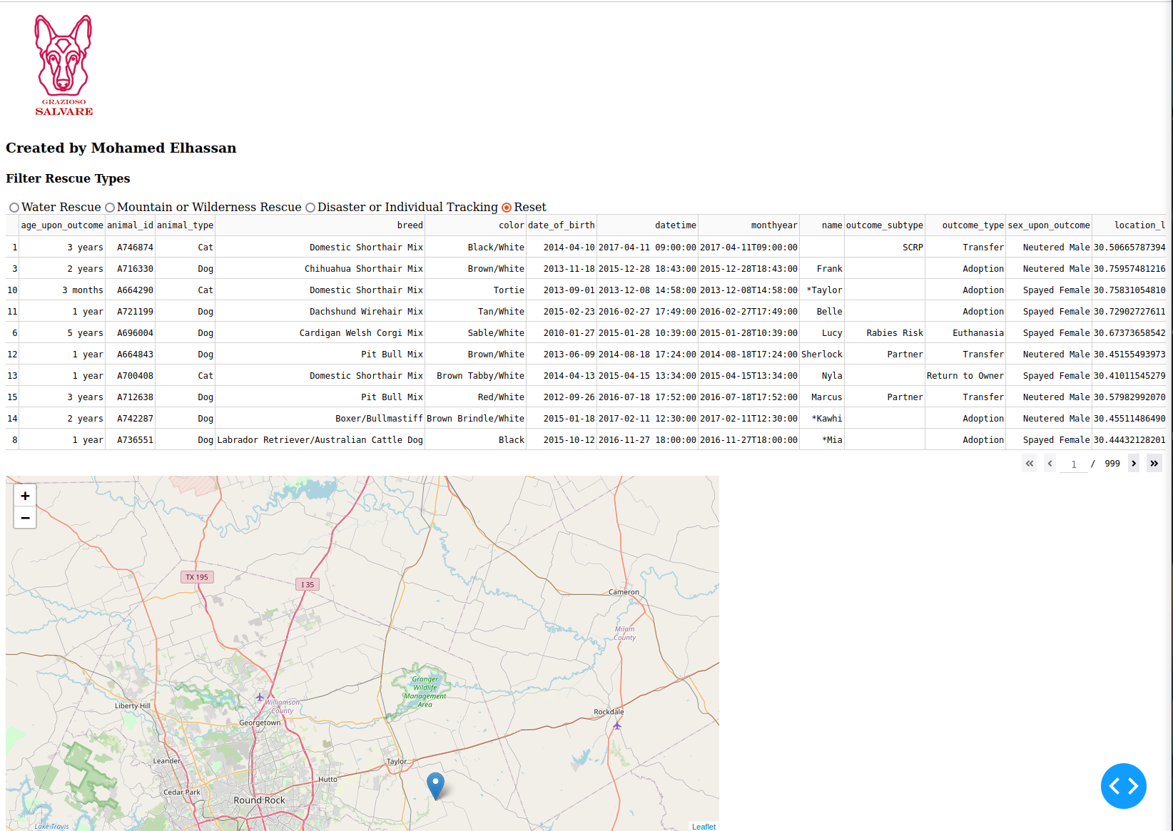

**- Filtered results for each rescue type (Water Rescue).**  
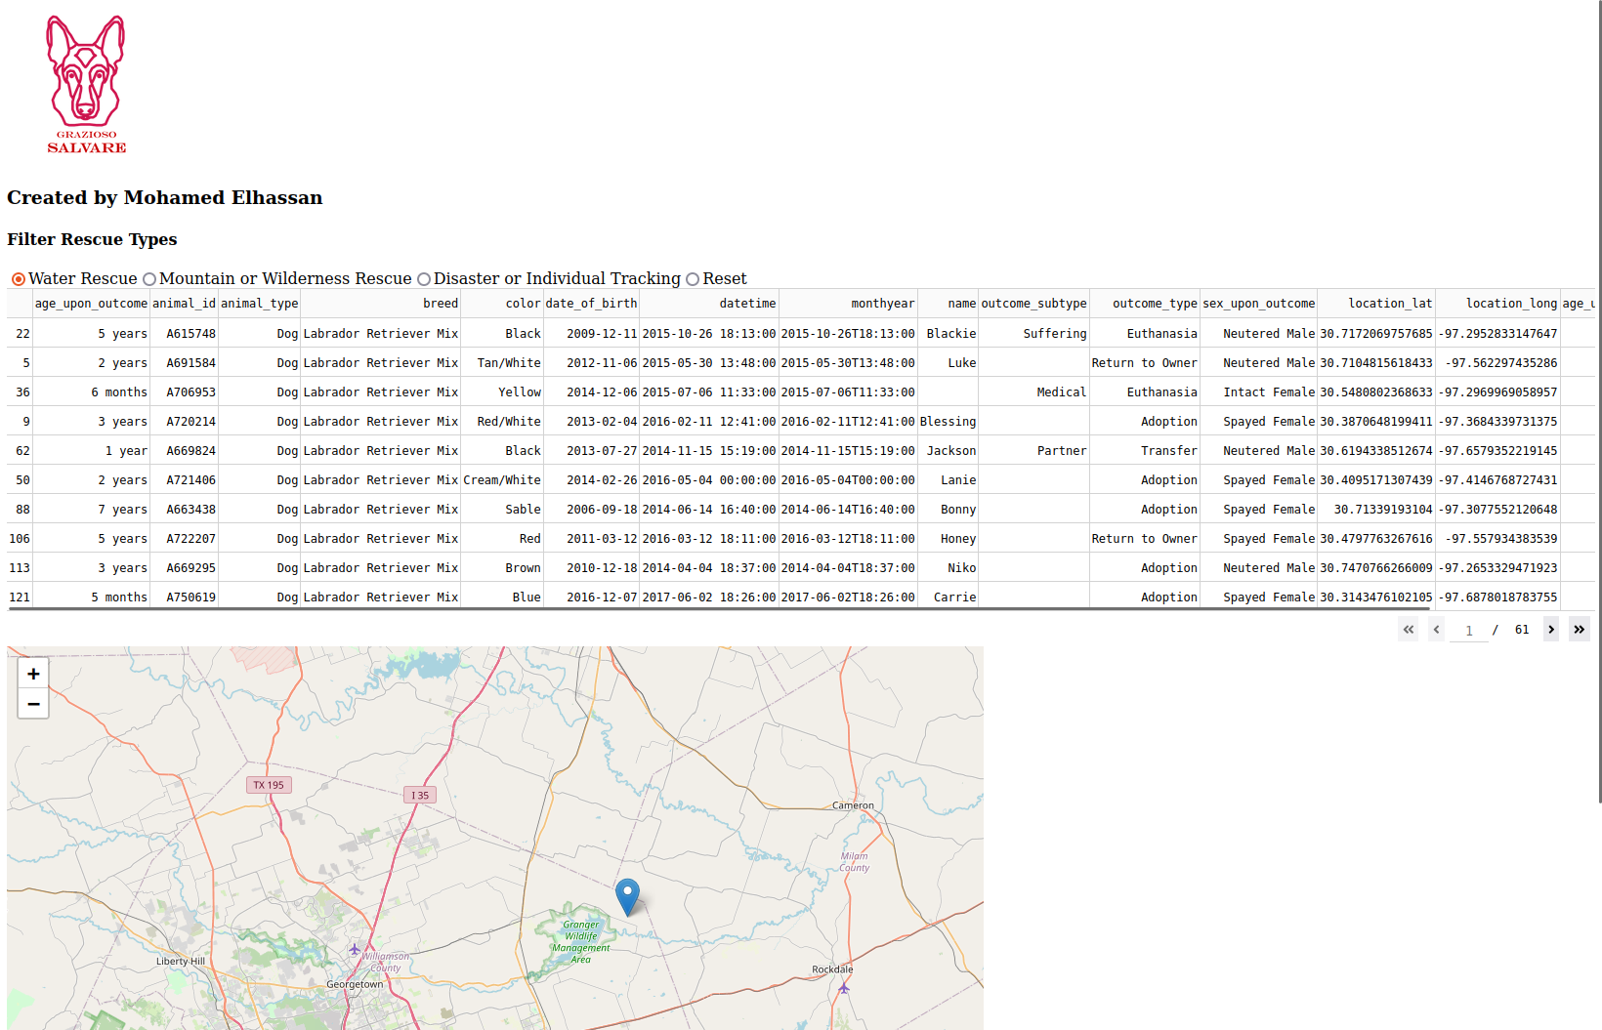

**- Filtered results for each rescue type (Mountain or Wilderness Rescue).**  
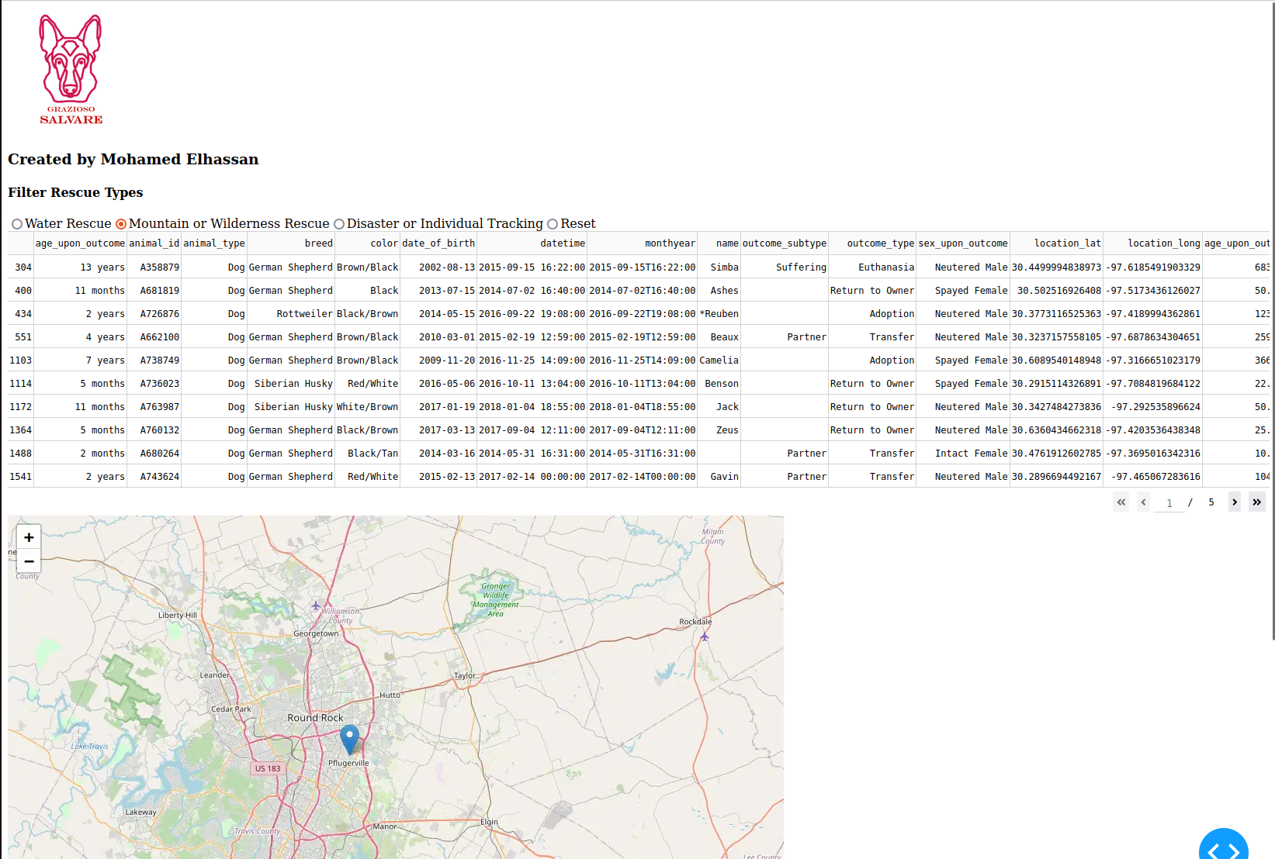

**- Filtered results for each rescue type (Disaster or Individual Tracking).**  
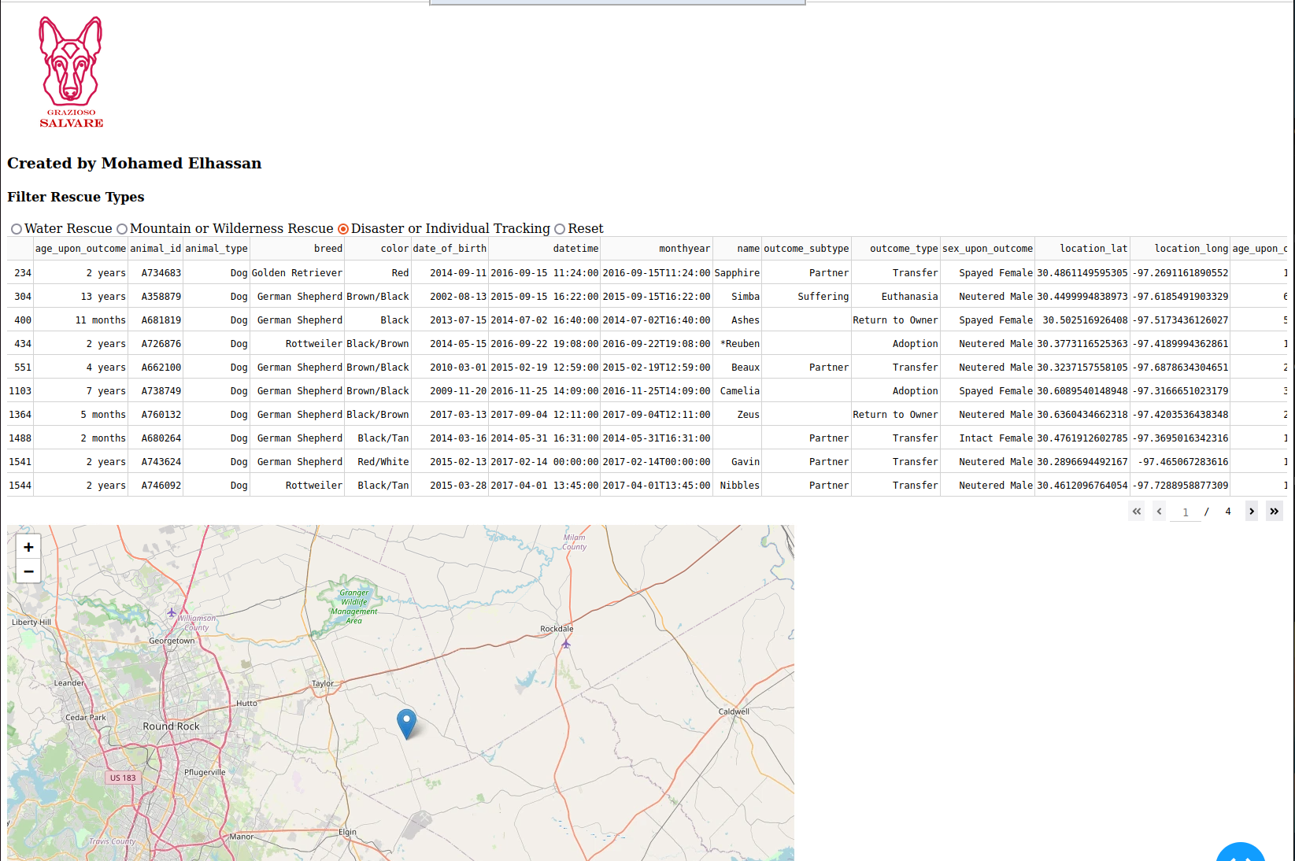  
**- Pie chart displaying breed distribution.**  
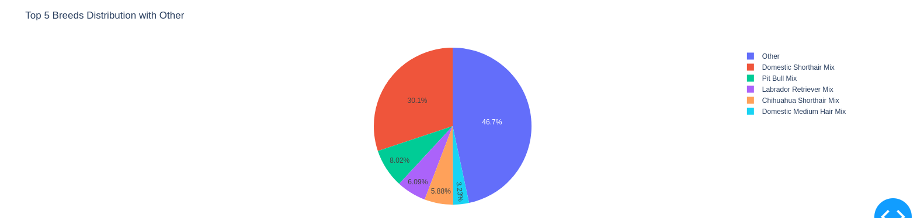

## Challenges and Solutions

### Pie Chart Readability

Initially, the pie chart displayed too many small breed slices, making it hard to read. This was addressed by grouping smaller breed categories into an "Other" group, while displaying only the top 5 most common breeds.

### Map Zoom and Interactivity

The dashboard was updated to zoom in on a selected animal's location to make the map more intuitive. If no animal is selected, the map defaults to the Austin, TX, area where the shelters are located.

## License

This project is open source and licensed under MIT License.